class Pet:

def __init__(self, name, hunger=5, energy=5, happiness=5):

self.name = name

self.hunger = hunger

self.energy = energy

self.happiness = happiness

def eat(self):

self.hunger = max(0, self.hunger - 3)

self.happiness = min(10, self.happiness + 1)

print(f"{self.name} has eaten and feels happier!")

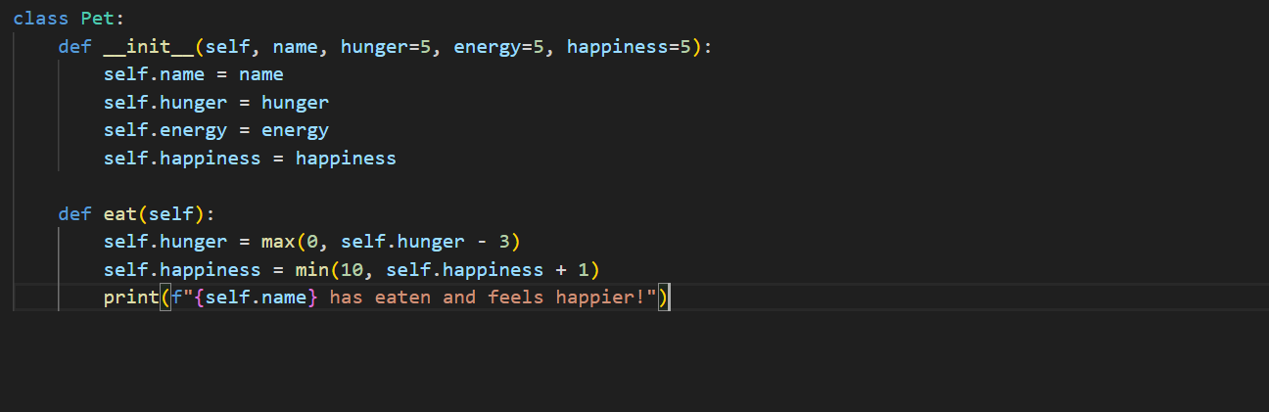

def sleep(self):

self.energy = min(10, self.energy + 5)

print(f"{self.name} had a good rest and feels recharged!")

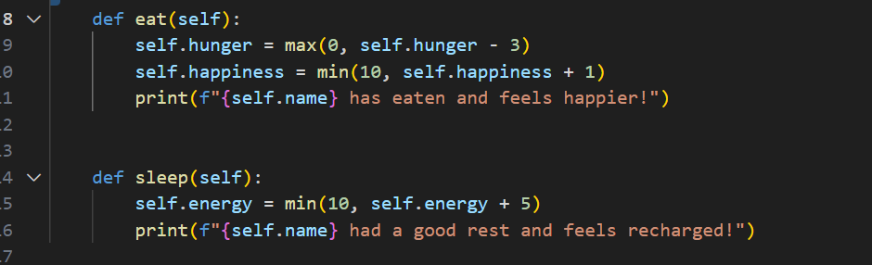

def play(self):

if self.energy >= 2: # Ensuring the pet has enough energy to play

self.energy -= 2

self.happiness = min(10, self.happiness + 2)

self.hunger = min(10, self.hunger + 1)

print(f"{self.name} had fun playing!")

else:

print(f"{self.name} is too tired to play and needs to rest.")

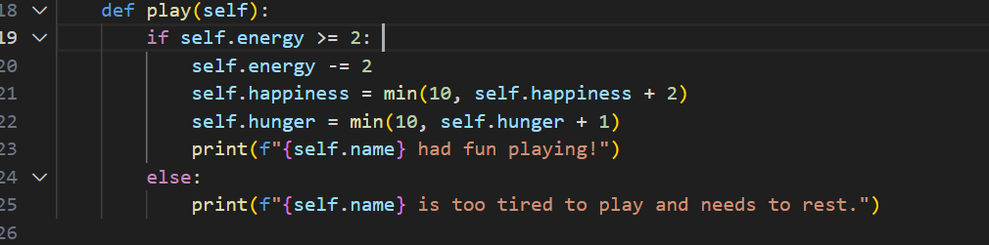

def get_status(self):

print(f"Pet Status - Name: {self.name}, Hunger: {self.hunger}, Energy: {self.energy}, Happiness: {self.happiness}")



my_pet = Pet("Spothi")

my_pet.get_status()

my_pet.eat()

my_pet.get_status()

my_pet.play()

my_pet.get_status()

my_pet.sleep()

my_pet.get_status()